Two Cents a Meal
Sunday, March 29
The 2 Cents a Meal Offering helps support our Grace Cares Food Pantry and other Presbyterian food assistance programs. Just set aside 2 cents for each meal you have during the month and show thanks to God for what you have received and to help others in need. You may leave your offering in the wooden bowl in the narthex following the worship service.

Wonderful Wednesday Dinner
Wednesday, April 1
There will be no Wonderful Wednesday this week.

Maundy Thursday Worship Service
Thursday, April 2
The congregation at Grace is invited to join the members of
First Presbyterian, Lynn Haven for a Maundy Thursday Tenebrae Service. The service will be at First Presbyterian, Lynn Haven on April 2 at 5:00 pm and led by their new interim minister.
We hope to see as many of you there as possible!

Easter Sunday
Sunday, April 5
Please join your church family and friends for an Easter celebration including breakfast (9:00am), Easter egg hunt (9:30am), pictures with the Easter Bunny (10:00am), worship (10:30am), and lunch which will be immediately following worship. Ham, fried chicken, rolls, tea, and dessert will be provided. We are kindly asking everyone to bring their favorite vegetable, potato dish, salad, deviled eggs, etc. to complement the lunch offerings. If you have any questions, please see Jan Pitts.
Thank you and we will see you on Easter!!!

One Great Hour of Sharing
Sunday, April 5
Sunday, April 5 is our One Great Hour of Sharing Offering.
This offering supports the Presbyterian Disaster Assistance,
the Presbyterian Hunger Program, and the Self-Development of People - all work in different ways to serve individuals and communities in need. From initial disaster response to ongoing community development, their work fits together to provide people with safety, sustenance, and hope.

Preschool Prom
Saturday, April 11
Join us for Grace Preschool Prom on April 11, 2026,
from 4:30 pm - 6:30 pm for a fun Sock Hop-themed evening! Tickets are $5 per student and
$10 for additional family members.
Sponsor a table for $25 and we'll advertise your business.
Tickets on sale March 23-April 8.
All proceeds benefit Teacher Appreciation Week!

Monday 3/30
9:00 am TOPS Weight Loss Support Group Meeting
(Bell Hall)

Tuesday 3/31
9:20 am Preschool Chapel 2’s (Sanctuary)
9:30 am Grace Bridge (Parlor)
11:00 am Preschool Chapel 1’s (Nursery)
11:15 am Preschool Chapel 3’s & 4’s (Sanctuary)
2:00 pm GP2 – Grace Prays at 2
4:30 pm Yoga Bliss (Bell Hall)
5:30 pm Handbell Practice (Music Room)
6:00 pm Scout Pack 850 (Bell Hall, Rooms 202, 204, 205)
6:30 pm Scout Troop 850 (Bell Hall)

Wednesday 4/1
9:00 am St. Andrew Quilt Guild Sewcial (Bell Hall)
9:00 am Barb’s 3’s Easter Party (Youth Room)
11:00 am St. Andrew Quilt Guild Busy Bee Meeting (Room 202)
6:15 pm Choir Practice (Music Room)

Thursday 4/2 Maundy Thursday
8:15 am Grace Cares Food Pantry (Front Entrance)
1:30 pm PWCT Meeting (Room 202)
3:30 pm Yoga Bliss (Bell Hall)
4:00 pm Beach Drive Preservation Club Meeting (Room 202)
5:00 pm Maundy Thursday Service
(First Presbyterian, Lynn Haven)
7:00 pm Bay County Stamp Club Meeting (Room 202)

Friday 4/3 Good Friday
Church Office & School Closed

Saturday 4/4
8:00 am St. Andrew Quilt Guild Beginners Sewing Class
(Bell Hall)

Sunday 4/5 Easter Sunday
9:00 am Breakfast (Bell Hall)
9:30 am Easter Egg Hunt (Bell Hall)
9:45 am Music Rehearsal (Sanctuary)
10:00 am Pictures with the Easter Bunny (Bell Hall)
10:30 am Worship Service (Sanctuary)
11:30 am Easter Lunch (Bell Hall)

Welcome
To
“The Blend”

Grace Presbyterian Church

10:30 am
Worship Service

Aug. 4, 2013



Small enough to
feel like family...
Big enough to
make an impact!

March 29, 2026
Rev. Eric Spoon

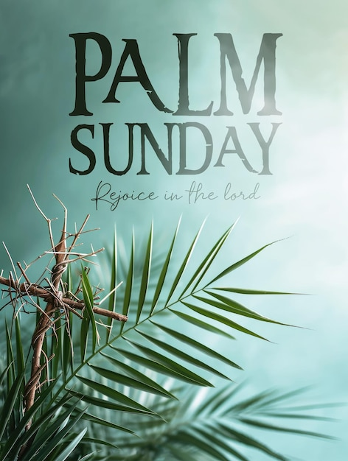

GATHERING AROUND THE WORD

Prelude

* Song of Praise “Hosanna, Loud Hosanna”
Hymn 197

Prayer For Worship Psalm 118: 1 - 4
Grady McDaniel, Elder

Announcements

Children’s Moment Lily Hoisington

* Passing of the Peace of Christ
Leader: The peace of the Lord be with you.
Congregation: And also with you.

Please take this time to greet one another.
First time worshiping with us?
Please fill out a visitor card and drop it in
an offering plate before you leave.

Special Music

Call to Confession

Prayer of Confession
Silent Prayer…
Holy God, sure of our faithfulness even in your dying, comforted by your compassion toward your people in every age, we beg your mercy for our paltry favors, when you have given everything. We have withheld from your people, our neighbors, and from your creation, our Earth, the care and tending they deserve. We have rejected the cornerstone you sent to build a people of righteousness even here, today. Forgive our failings. Heal what we have broken, nurture what we have neglected, and lead us to your vision, so that we may know the peace of wholeness in you; in Jesus’ name. Amen.

Assurance of Pardon

*Hymn 196 “All Glory, Laud, and Honor”
vs. 1, 4

PROCLAIMING THE WORD

Scripture Reading Matthew 21: 1 - 11

Leader: This is the Word of God for
the people of God.
All: Thanks be to God.

Sermon “Palm Branches” Rev. Eric Spoon

RESPONDING TO THE WORD

Offering of Gifts/Two Cents a Meal
Ways to Give
~ Offering Plate in the Narthex.
~ Offering Plate by the doors leaving the Sanctuary.
~ Anytime Online at our Church Website.
~ In Person in the Church Office During the Week.

* Hymn of Thanksgiving
“Praise God, from Whom All Blessings Flow”
Hymn 609

Prayer of Thanksgiving, Prayers of the People,
& the Lord’s Prayer
There will be a time of silence as part of the prayers
of the people. In the silence, you are invited to lift
your joys and concerns to the Lord. If you have a
prayer request card, please hold it up.

Our Father, who art in heaven, hallowed be Thy name.
Thy Kingdom come, Thy will be done, on earth as it is in heaven. Give us this day our daily bread; and forgive us our debts, as we forgive our debtors. And lead us not into temptation, but deliver us from evil. For Thine is the kingdom, and the Power and the Glory forever. Amen
Prayer Requests
Jerry & Peggy Lewis; Martha Patterson;
George Henderson; Marilyn Jasperson;
Victory International School & Chapel;
Myanmar Missionary Victor Vula

BEARING THE WORD INTO THE WORLD

* Service to the World Song “Give Thanks”
Hymn 647
* Charge & Benediction

* Benediction Response “How Great Thou Art”
Hymn 625, Refrain

* Postlude

* Please rise in body or in spirit.

Audio Assistant Devices for the hearing
impaired are available in the narthex.
Please ask an Elder if you need assistance.

The reproduction of all music in all
worship services and activities is protected by:
CCLI License No. 1368460,
CCLI Streaming License No. 20473151

Grace Presbyterian Church
1415 Airport Rd. Panama City, FL 32405
850-769-4000
Office Hours Mon.-Thurs. 8:00am – 5:00pm
Fri. 8:00am – 12:00pm
www.gracechurchpc.com

